**Project Output Screenshots**

**Compilation**



**Main Menu**

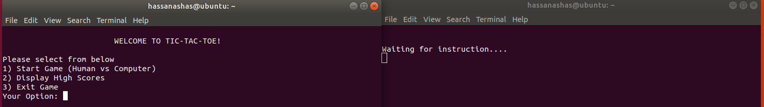

**Displaying High Scores (From File)**

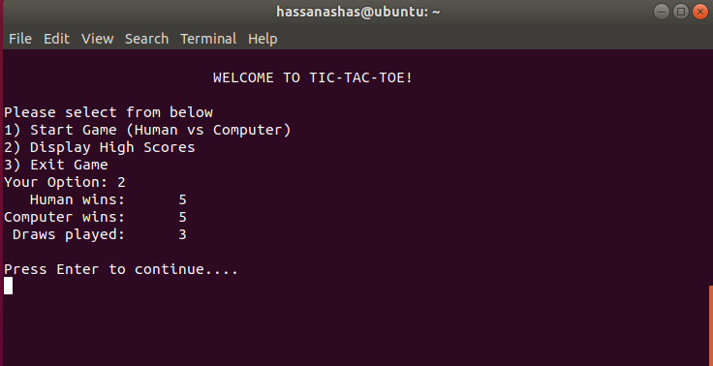

**Game Start**

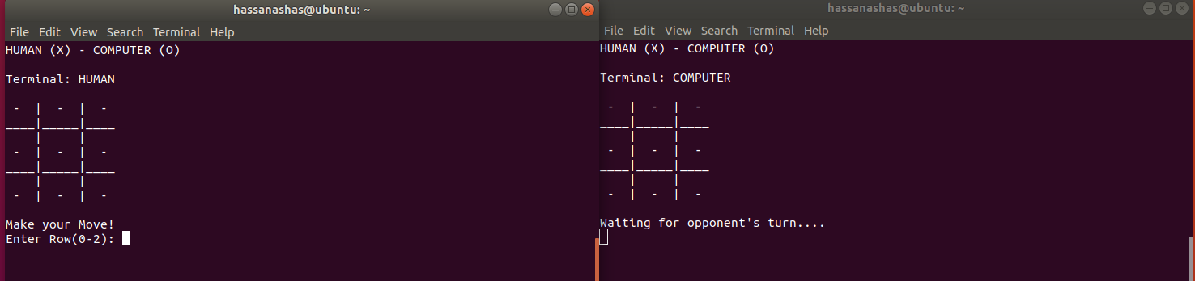

**Game Screenshots**

